6. Major Features and Modules

6.1 User Authentication Module

6.1.1 Overview
The authentication module provides secure user login, registration, and session management capabilities.

6.1.2 Features
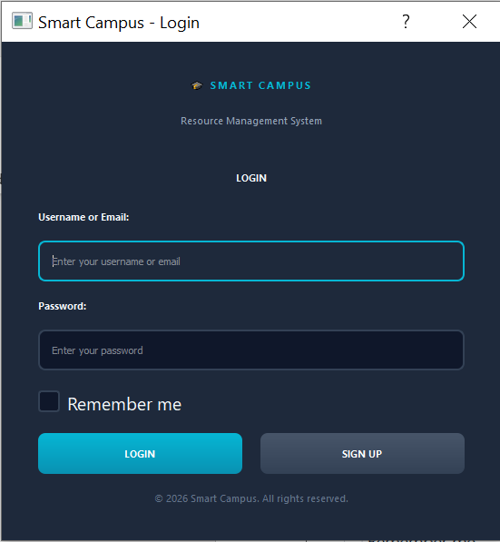
- User Registration: New users can create accounts with username, email, and password
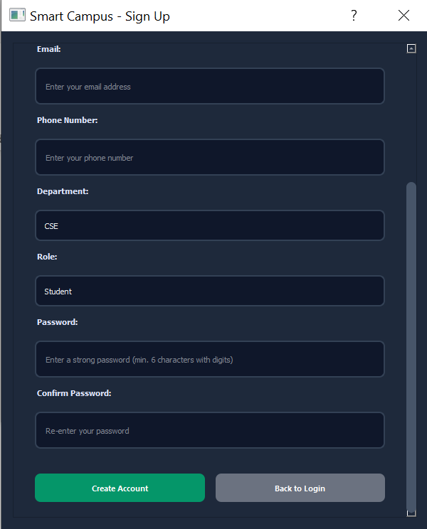

- Secure Login: Password hashing using MD5 for security
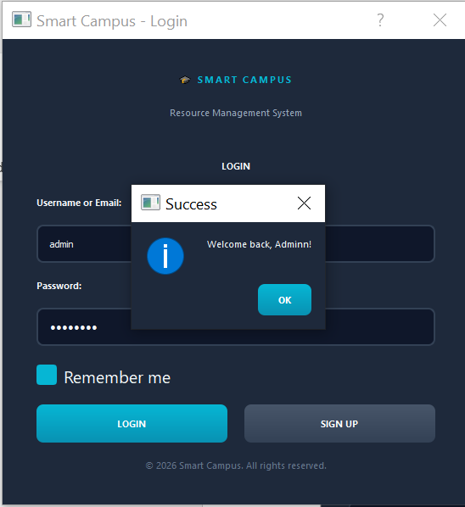
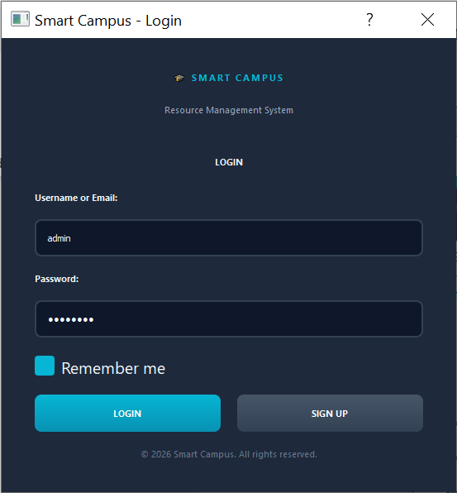

- Role-Based Access: Automatic dashboard routing based on user role
- Session Management: Maintains user session throughout application lifecycle
- Logout Functionality: Secure logout with session cleanup
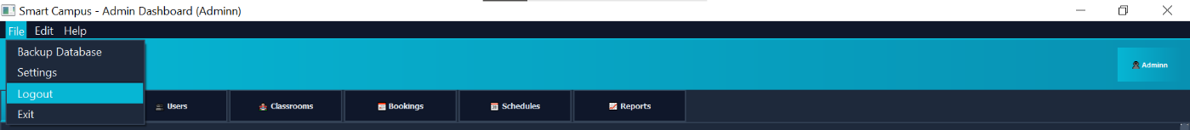

6.1.3 Implementation Details
Files: - gui/login_window.py: Login interface - gui/signup_window.py: Registration interface - models/user.py: User model with authentication methods
Key Methods:
User.login(username, password)
User.register()
User.hash_password(password)
User.get_user_by_id(user_id)
Security Measures: - Password hashing before storage - SQL injection prevention through parameterized queries - Session validation on each request - Account status verification (Active/Inactive)

6.1.4 User Roles
Role | ID | Permissions | Dashboard
Administrator | 1 | Full system access, approve bookings, manage all entities | Admin Dashboard
Teacher | 2 | Create bookings, view schedules, manage profile | User Dashboard (Teacher view)
Student | 3 | View schedules, manage profile | User Dashboard (Student view)

6.2 Resource Management Module

6.2.1 Overview
Manages all physical resources including classrooms, labs, and equipment across the campus.
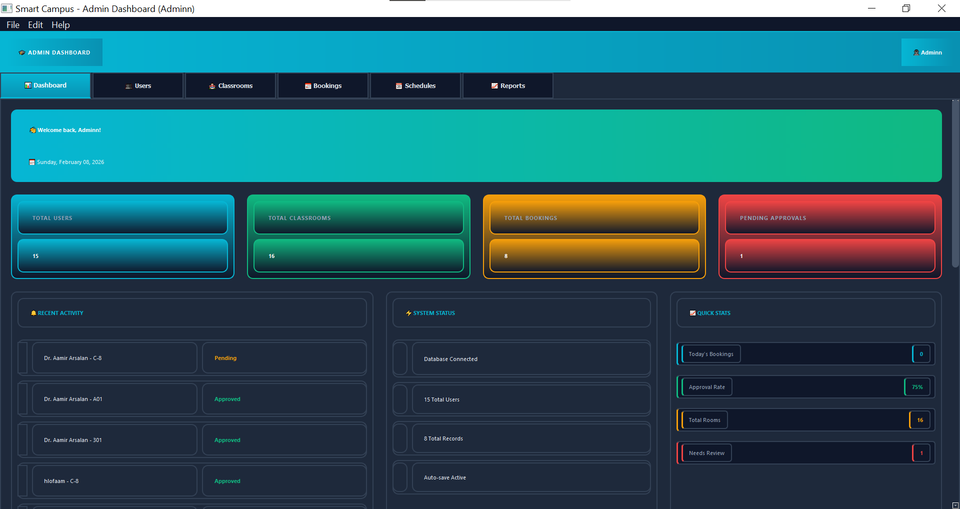
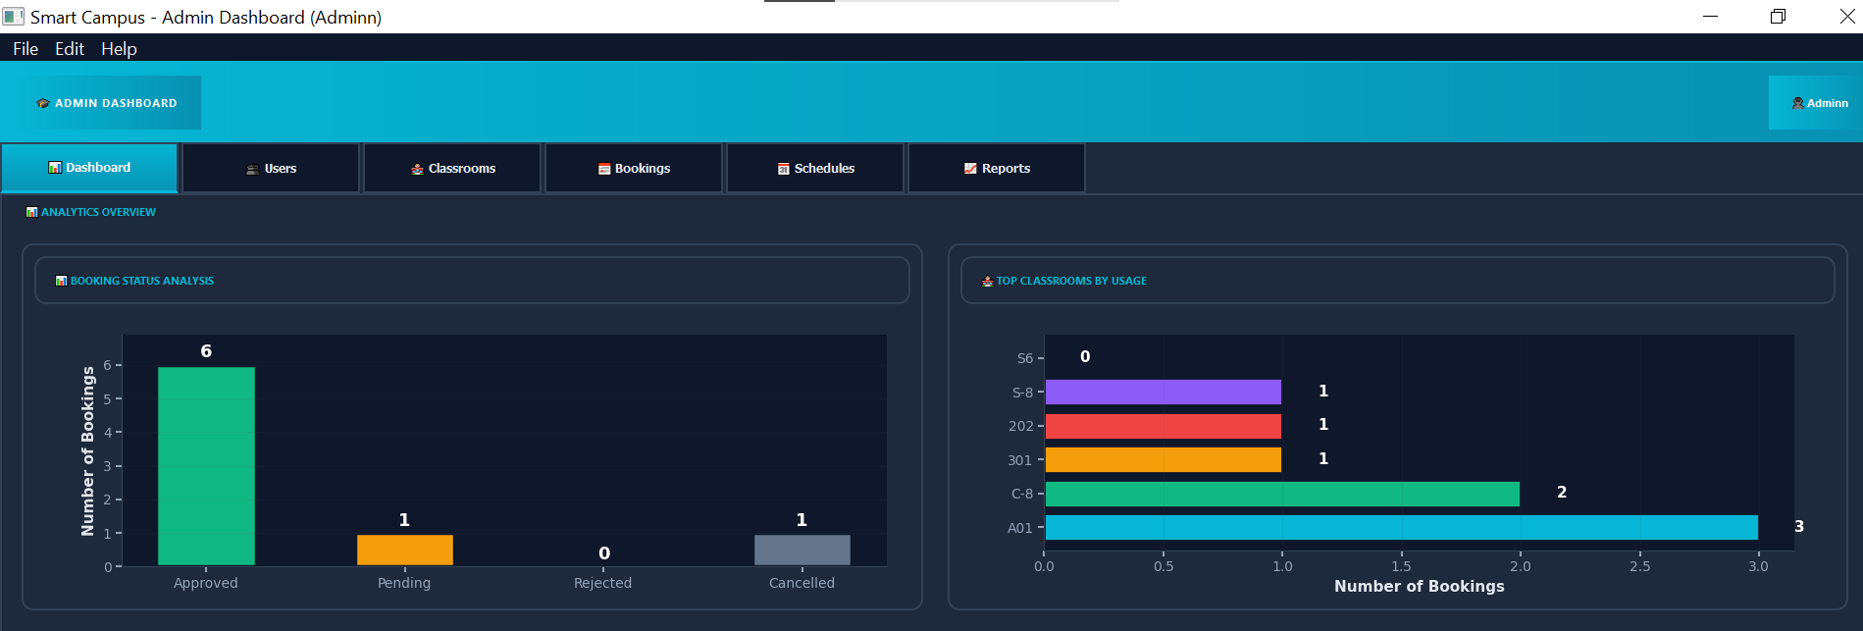
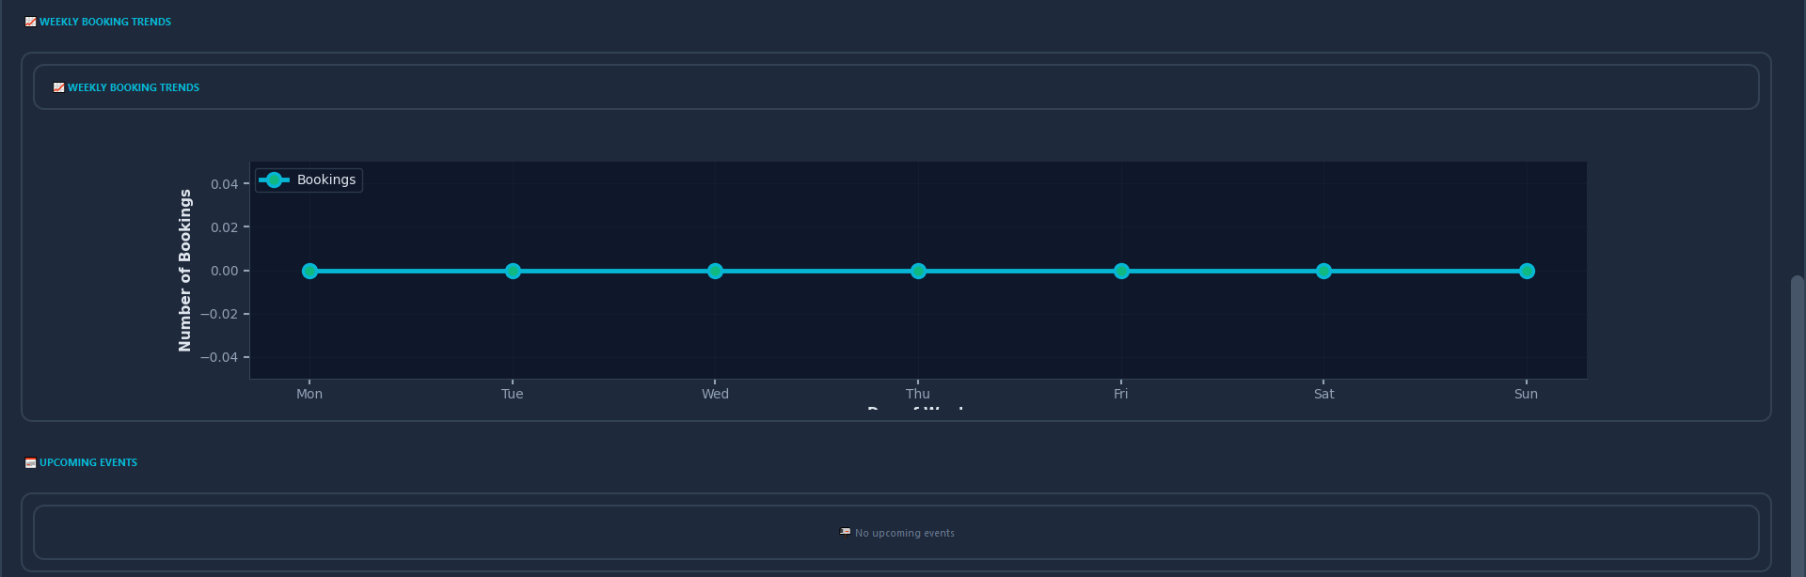

6.2.2 Classroom Management
Features: - Add new classrooms with detailed specifications
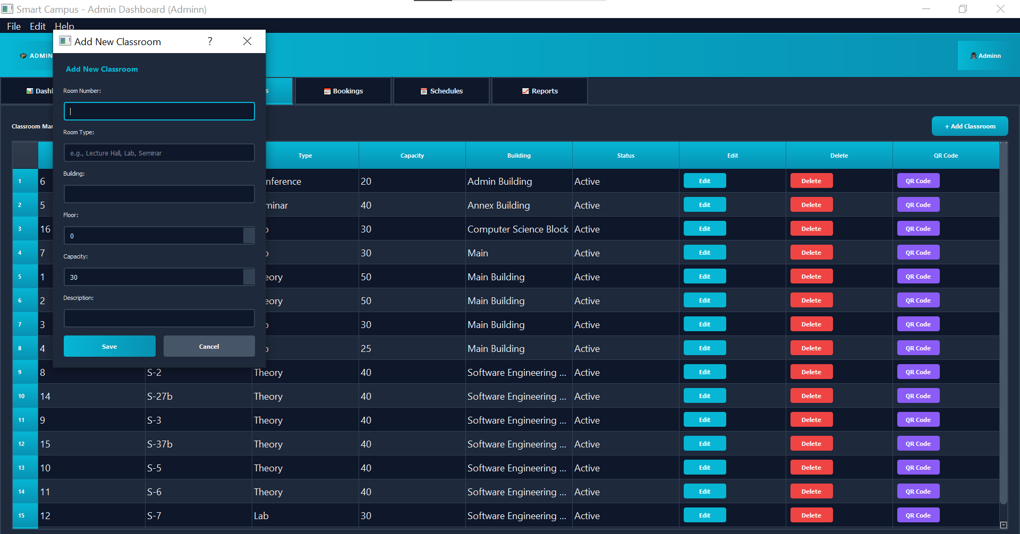
-Edit classroom information
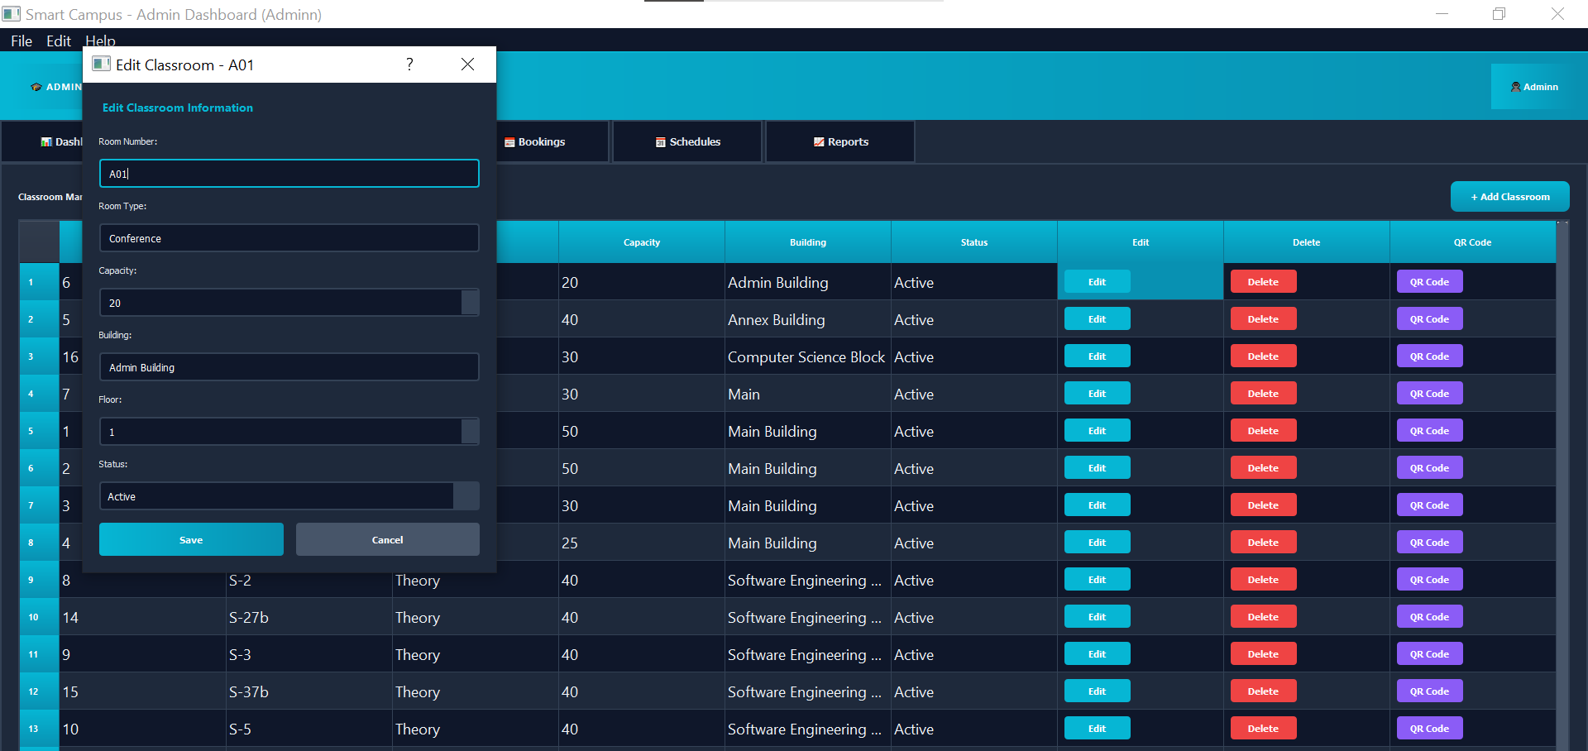

- Delete classrooms (with confirmation)
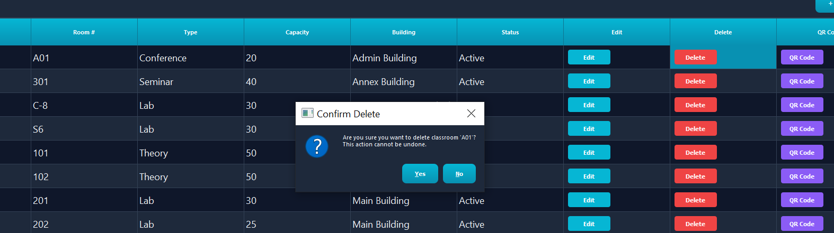
- View all classrooms in tabular format - Search and filter classrooms - Track classroom status
- Generate QR codes for classrooms
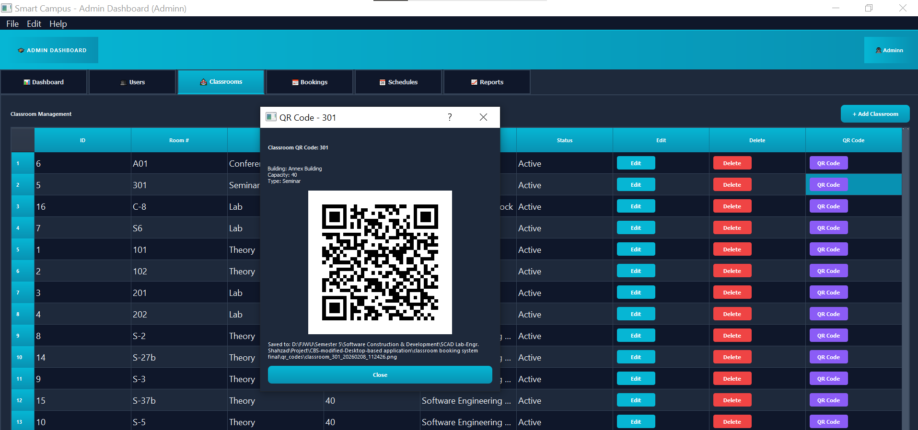
Classroom Attributes: - Room Number (unique identifier) - Type (Theory, Lab, Seminar, Conference) - Capacity (student capacity) - Building location - Floor number - Amenities (Projector, AC) – Status
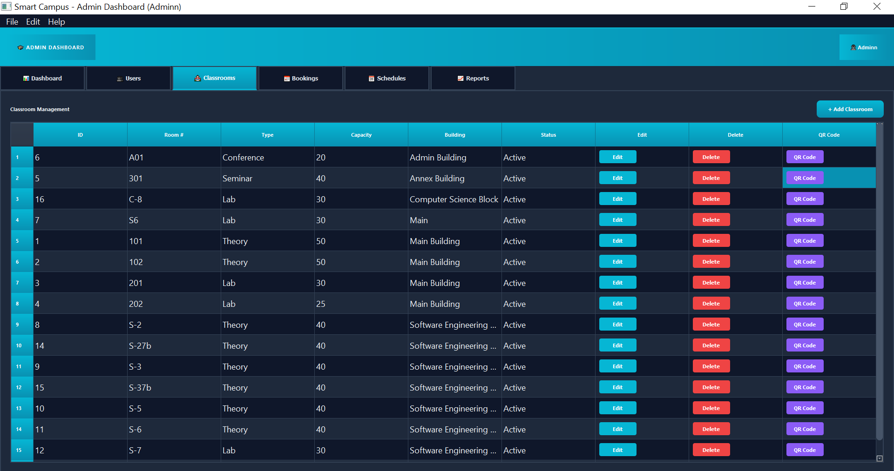

Implementation: - File: models/classroom.py - GUI: gui/admin_dashboard.py (Classrooms tab) - Dialogs: gui/dialogs.py (AddClassroomDialog), gui/dialogs_edit.py (EditClassroomDialog)
Key Methods:
Classroom.create()
Classroom.get_all()
Classroom.get_classroom_by_id(id)
Classroom.update()
Classroom.delete()

User Management:

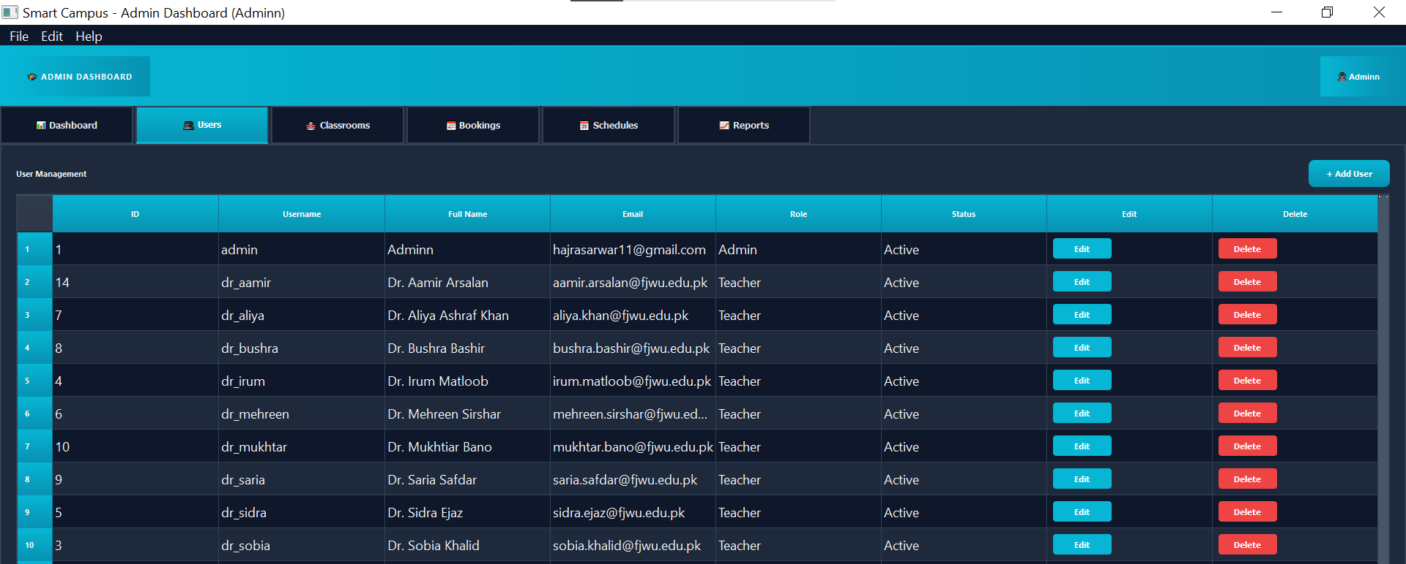

--Add User:
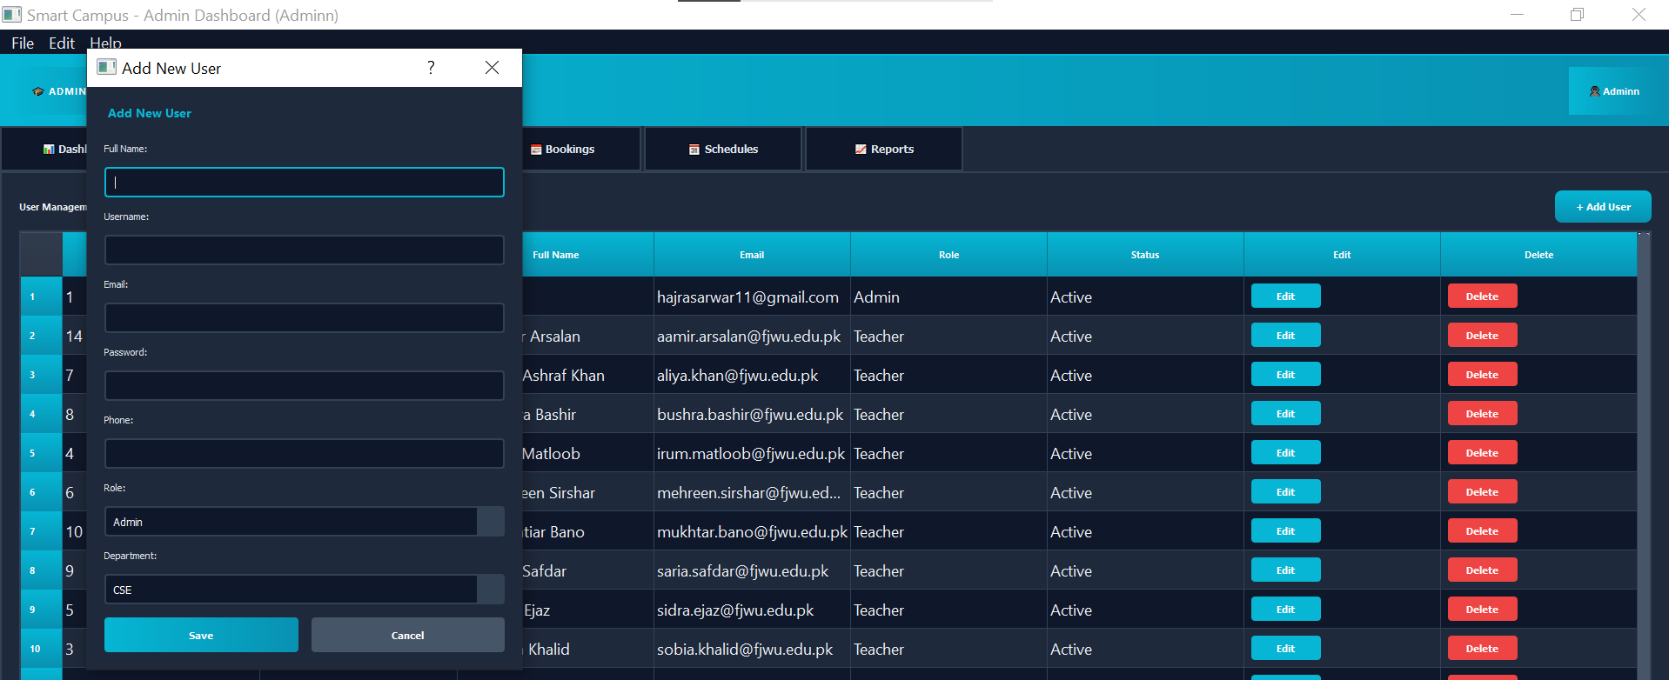
--Edit User:
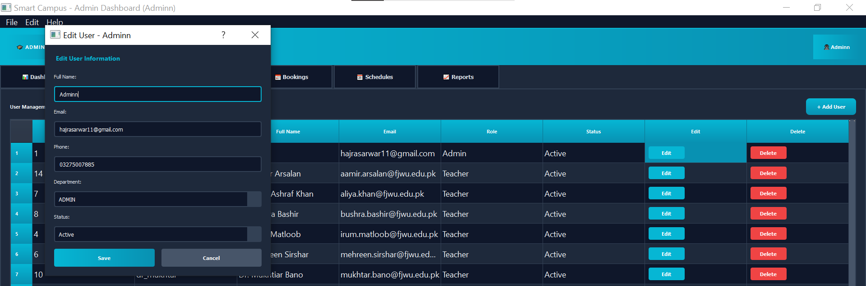

--Delete User:
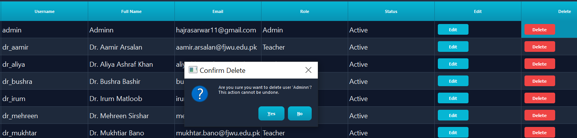

Booking Management:

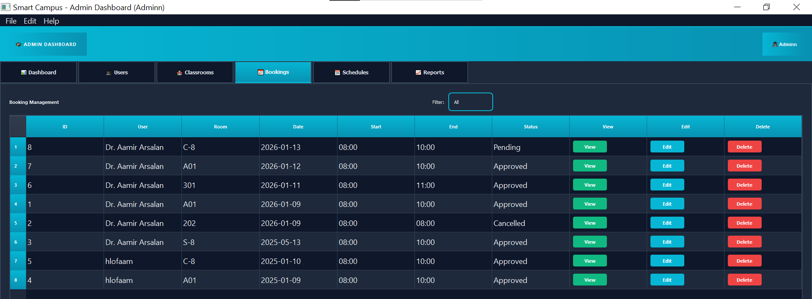

--View Booking:
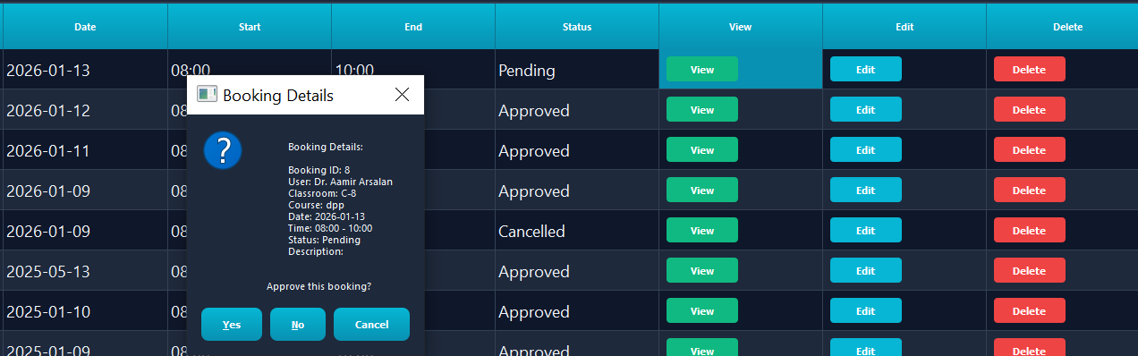
--Edit Booking:
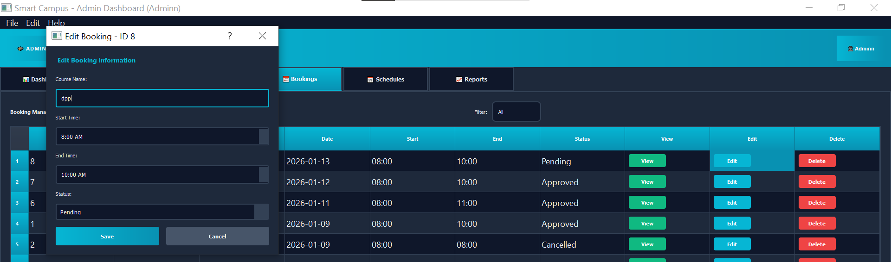
--Delete Booking:
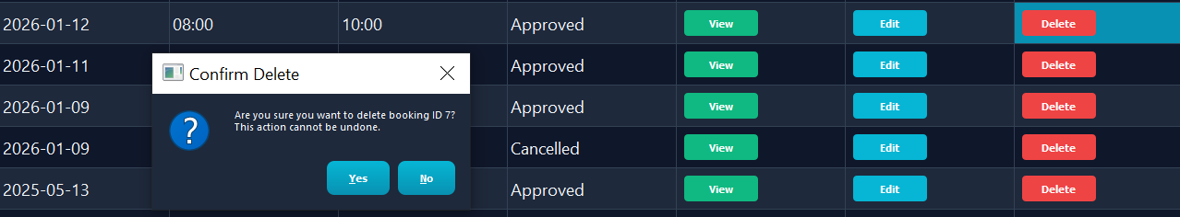
--Filter Bookings:
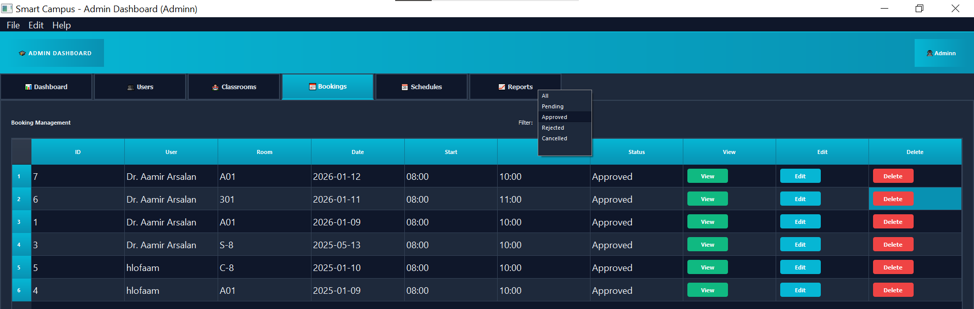

Schedule Management:

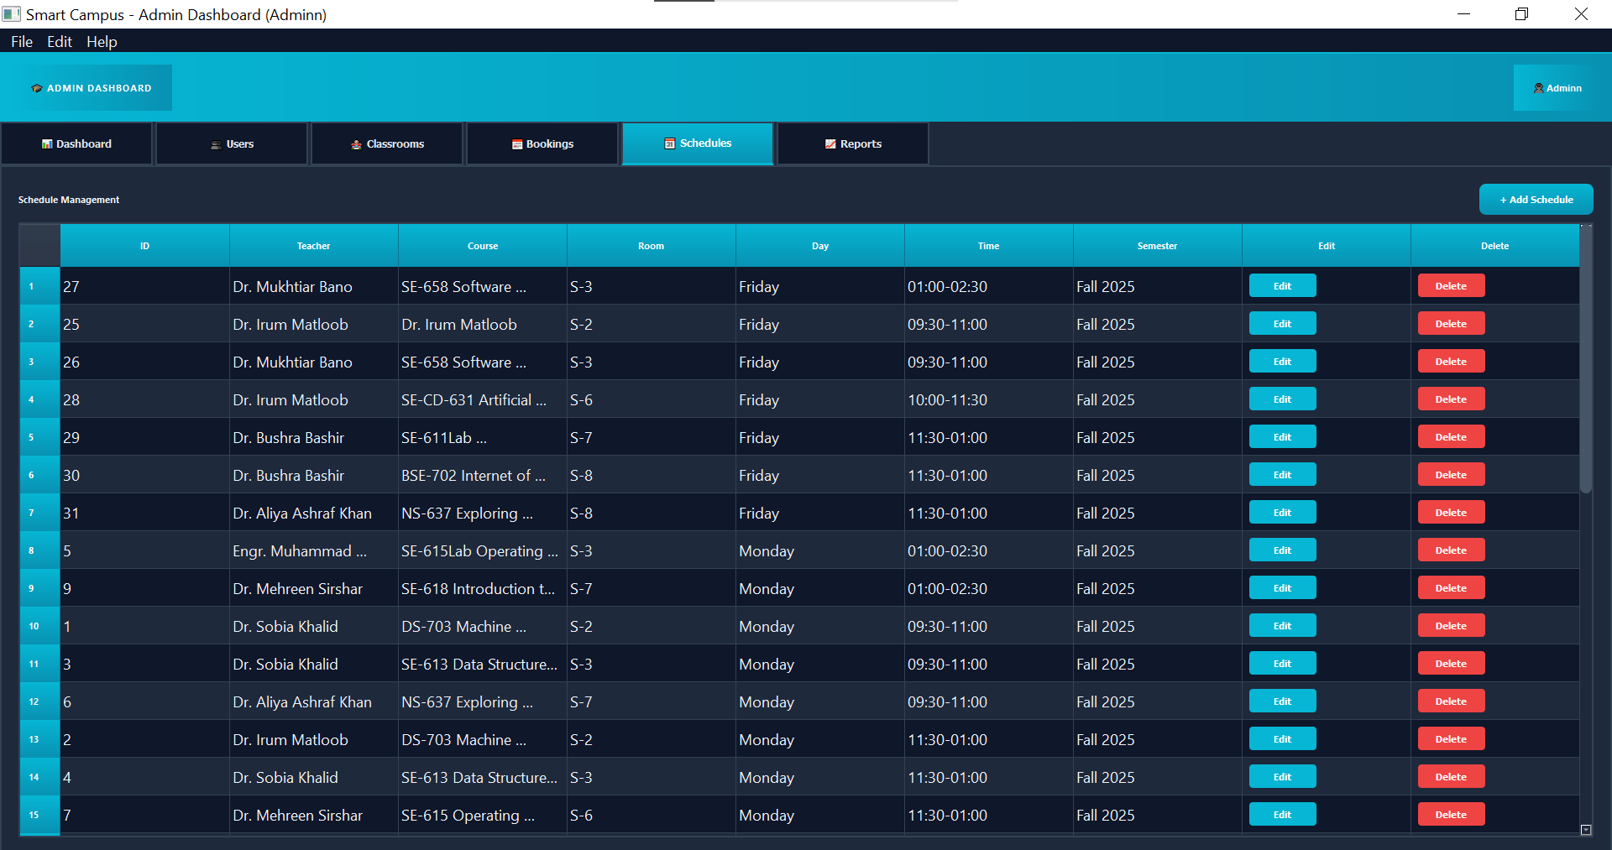

--Add Schedule:
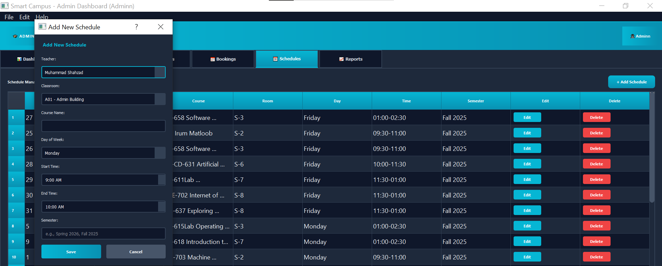
--Edit Schedule:
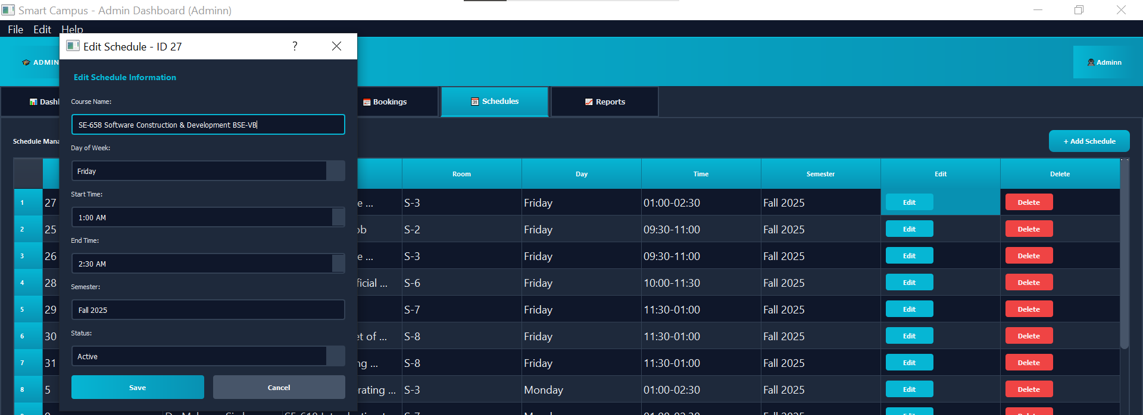

--Delete Schedule:
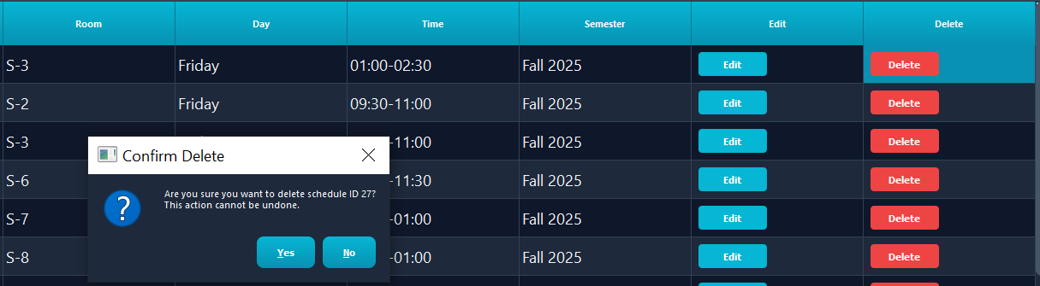

Reports Management:
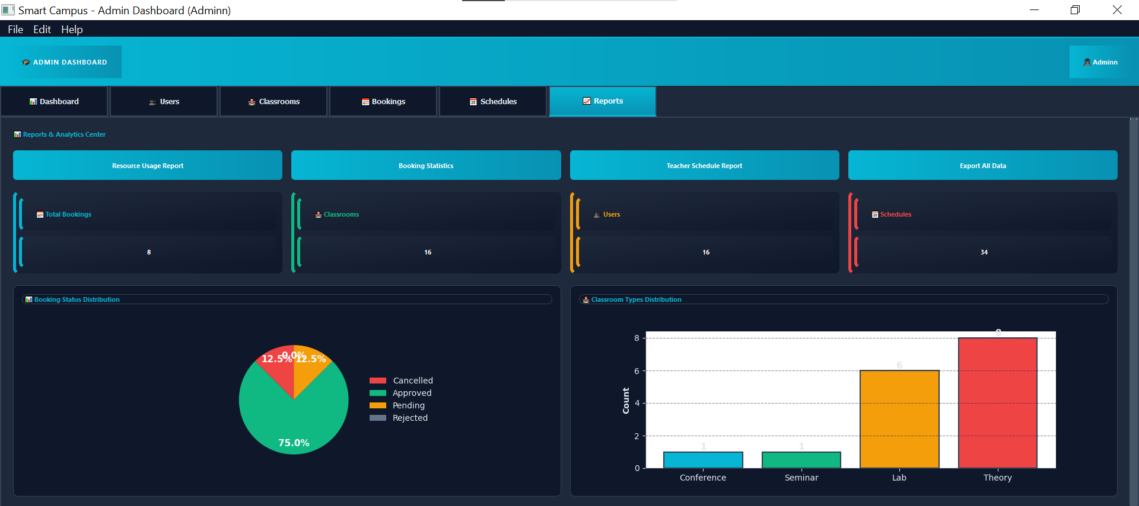

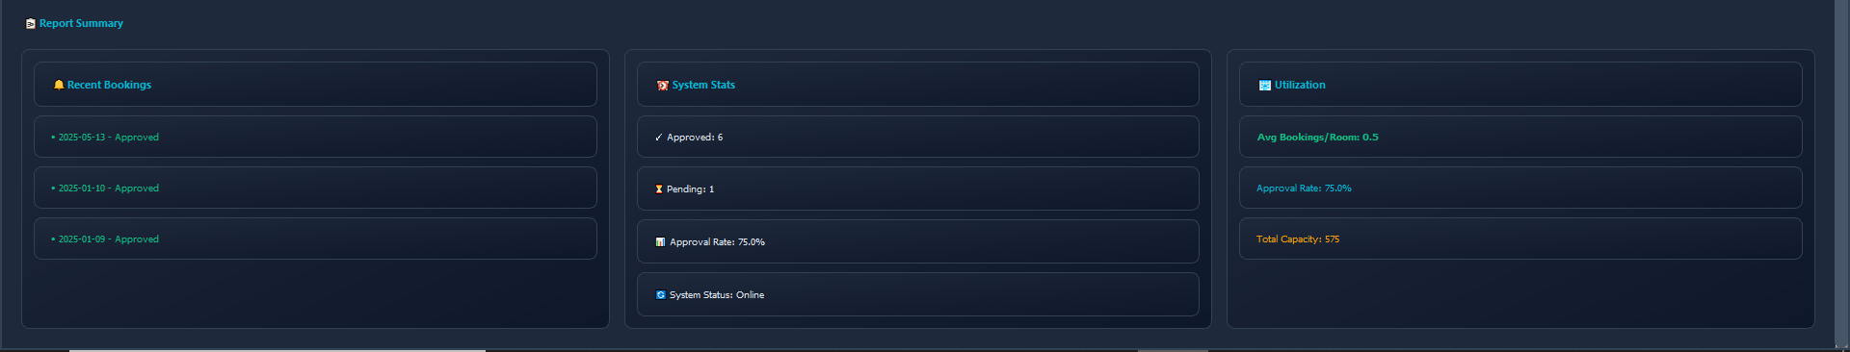
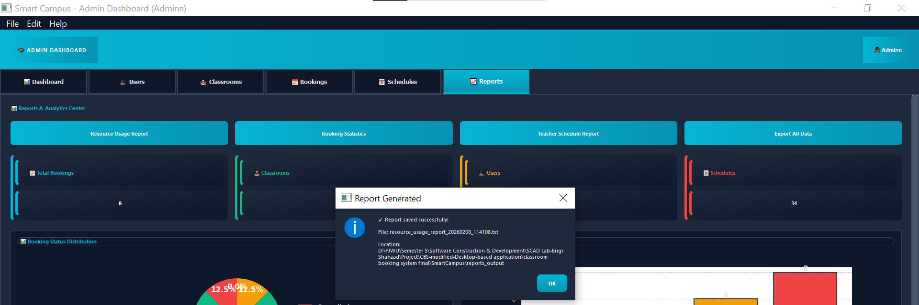
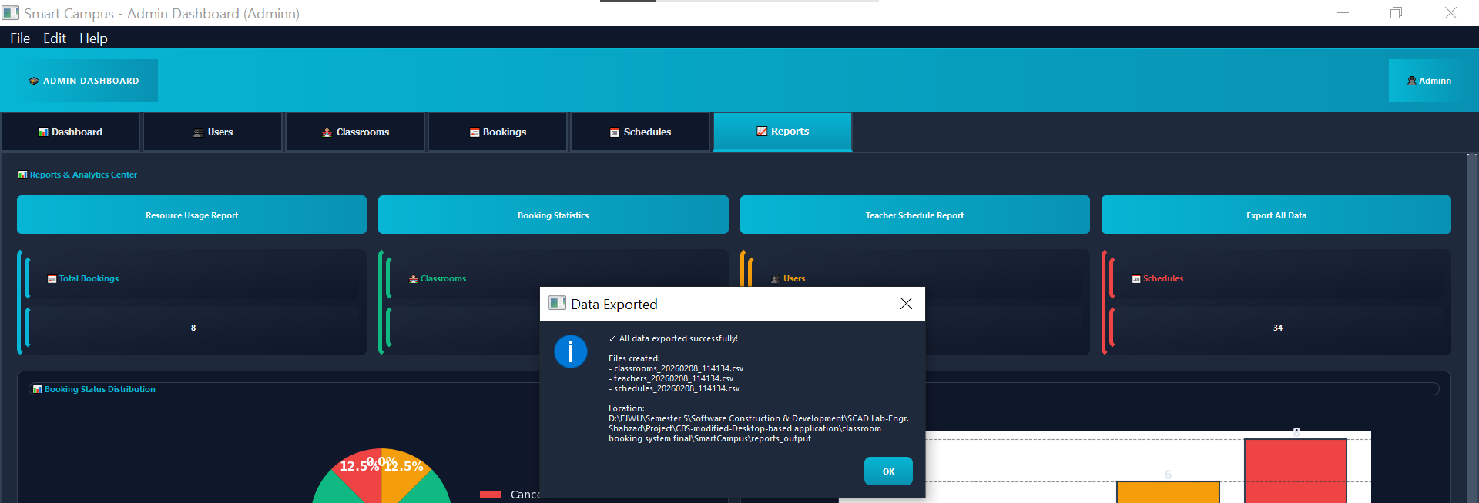

--Setting:
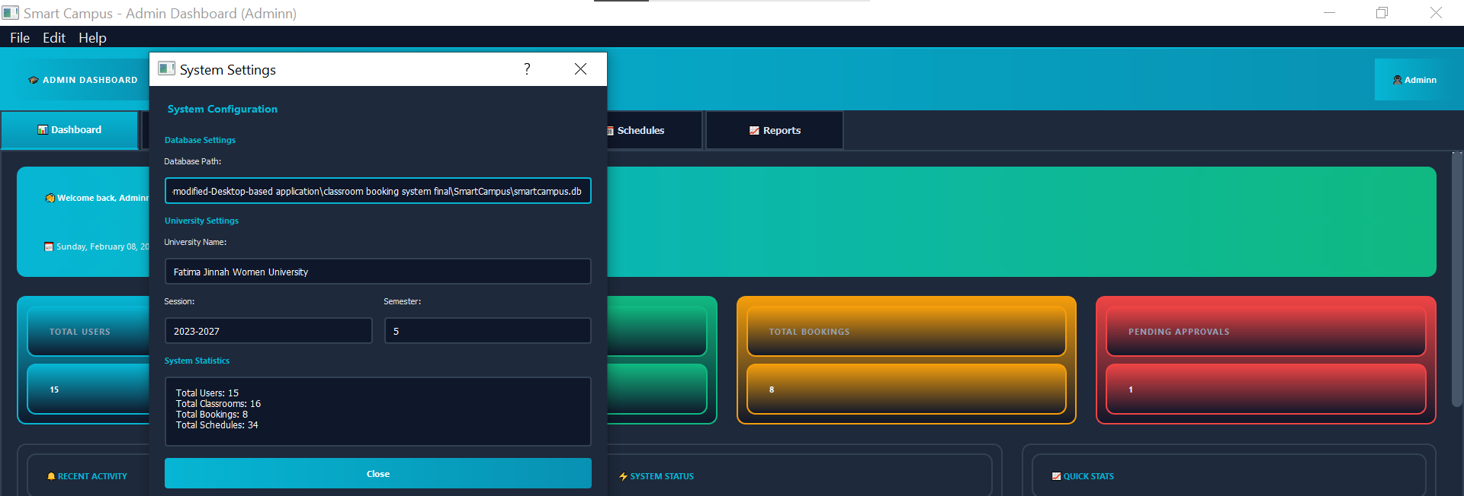
--Database:
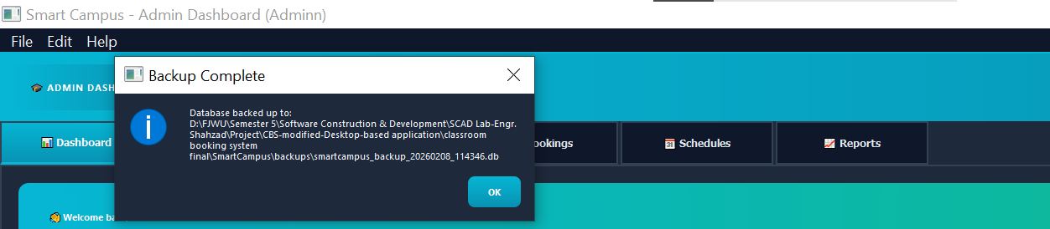

6.3 Booking Management Module

6.3.1 Overview
Handles classroom booking requests, approvals, and conflict detection.
--Teacher:
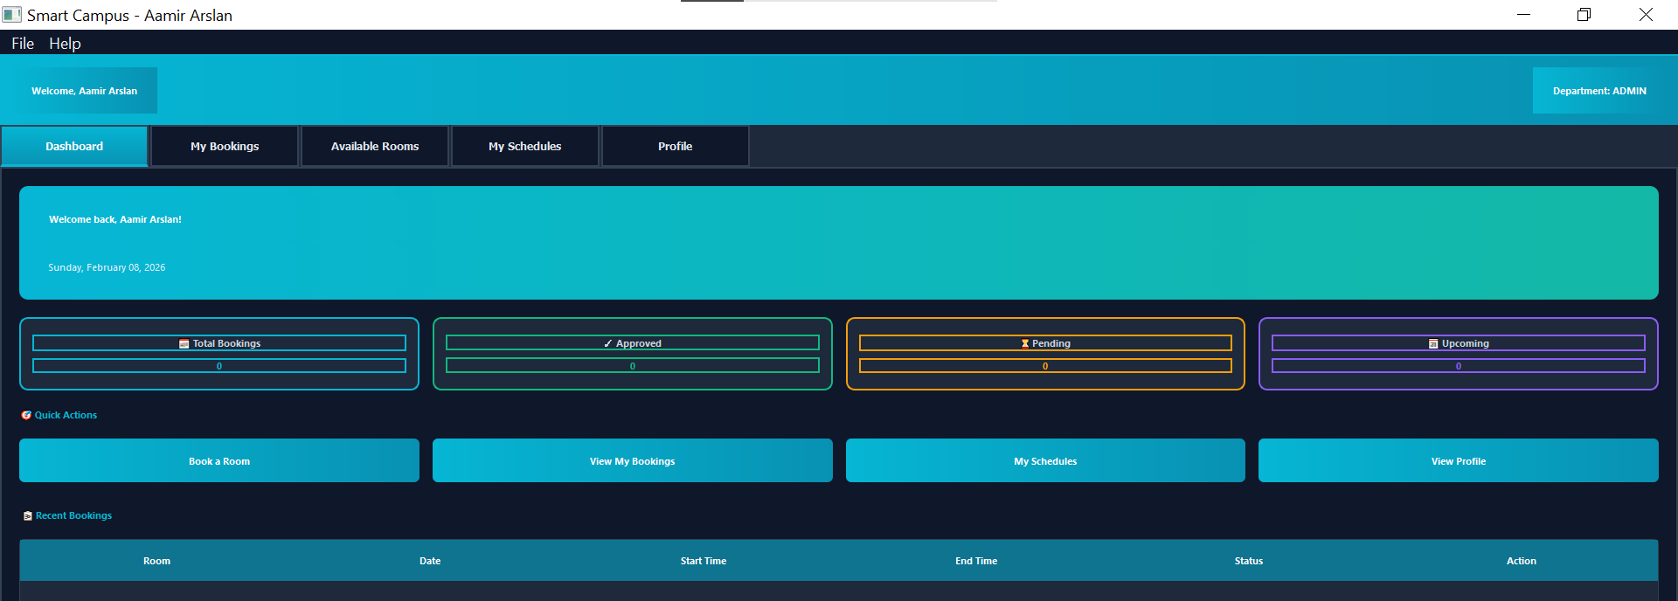

6.3.2 Features
For Users (Teachers/Students): - Create booking requests for classrooms
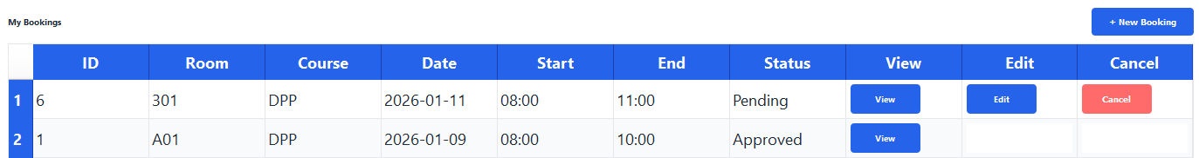
- View booking history
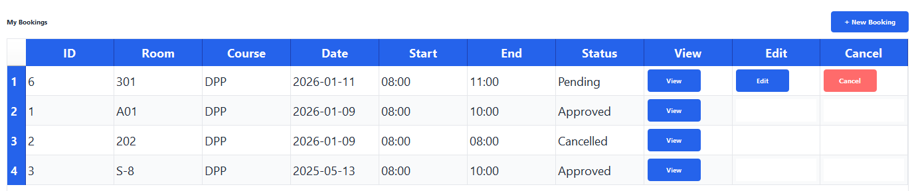
- Filter bookings by status
- Edit pending bookings
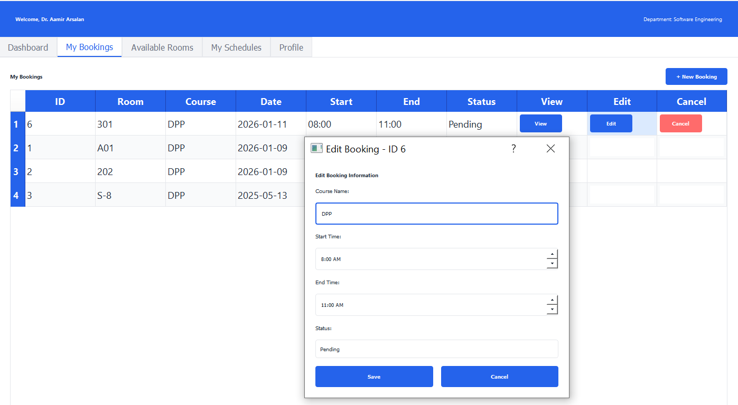
- Cancel bookings
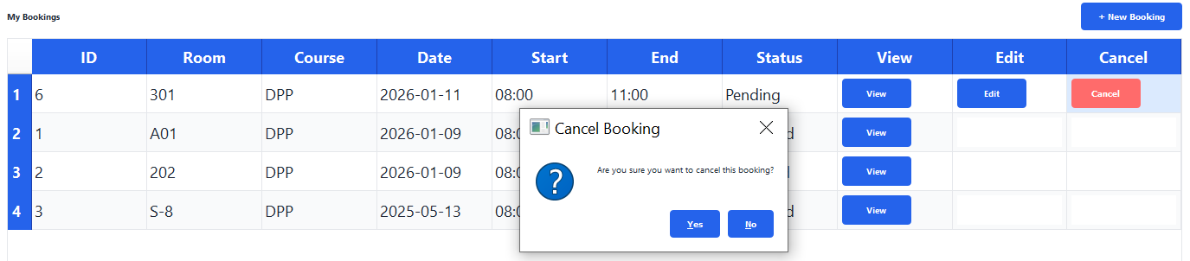
- Export booking data to CSV
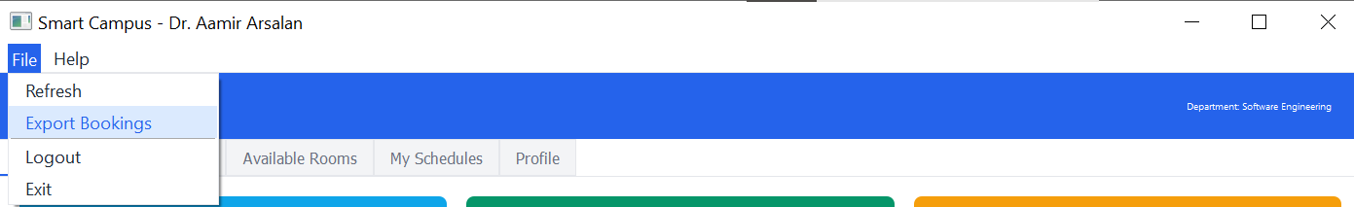

For Administrators: - View all booking requests
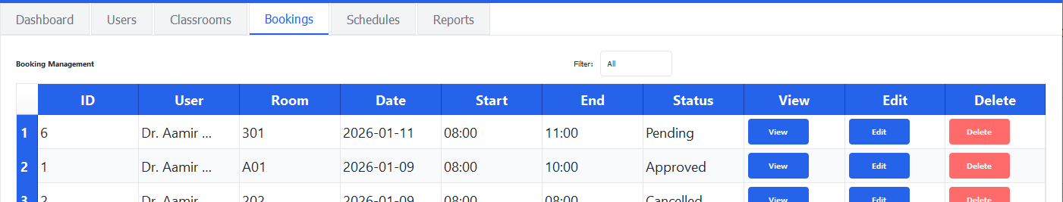
- Approve/reject bookings
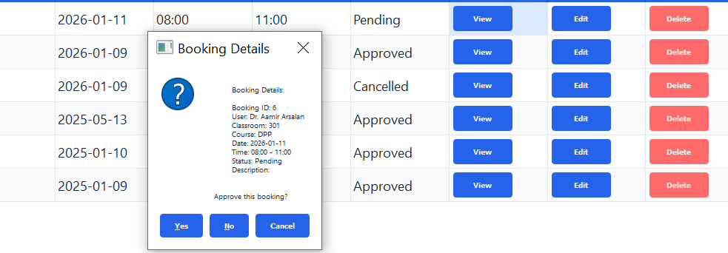
- Edit booking details
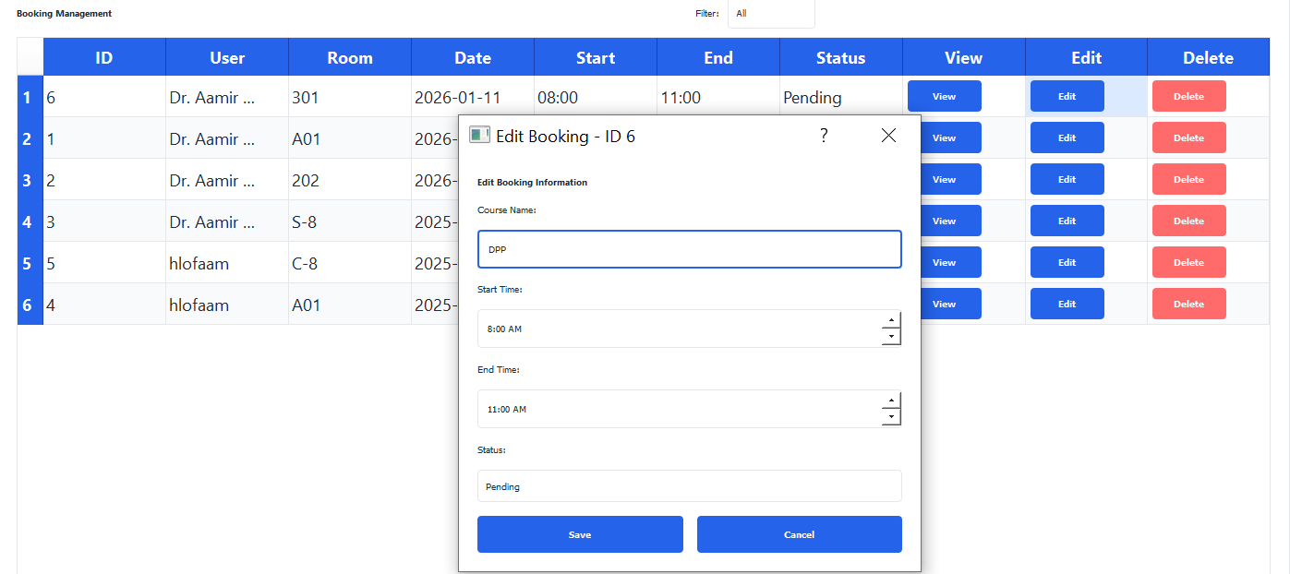
- Delete bookings - Filter bookings by status
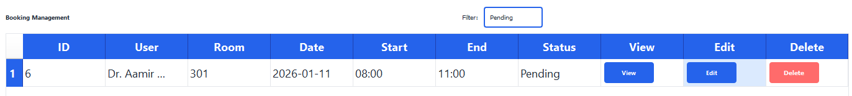

- Generate booking reports
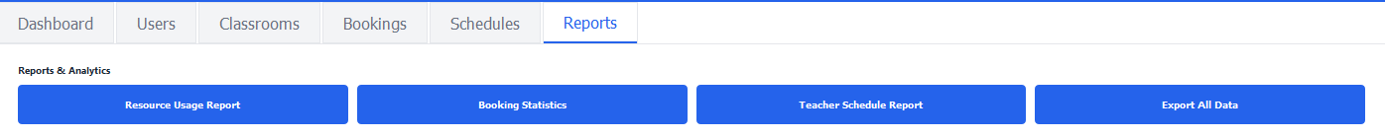

6.3.3 Booking Workflow
User creates booking request
↓
Status: PENDING (2)
↓
Admin receives email notification
↓
Admin reviews in dashboard
↓
┌────┴────┬────────┐
↓ ↓ ↓
APPROVED REJECTED CANCELLED
(1) (3) (0)
↓ ↓ ↓
User receives email with decision

6.3.4 Booking Status Codes
Status | Code | Description | Color
Cancelled | 0 | Booking cancelled by user or admin | Purple
Approved | 1 | Booking approved by admin | Green
Pending | 2 | Awaiting admin approval | Orange
Rejected | 3 | Booking rejected by admin | Red

6.3.5 Conflict Detection
The system automatically detects scheduling conflicts: - Same classroom cannot be booked for overlapping time slots - Checks date, start time, and end time - Prevents double bookings - Shows warning message if conflict detected
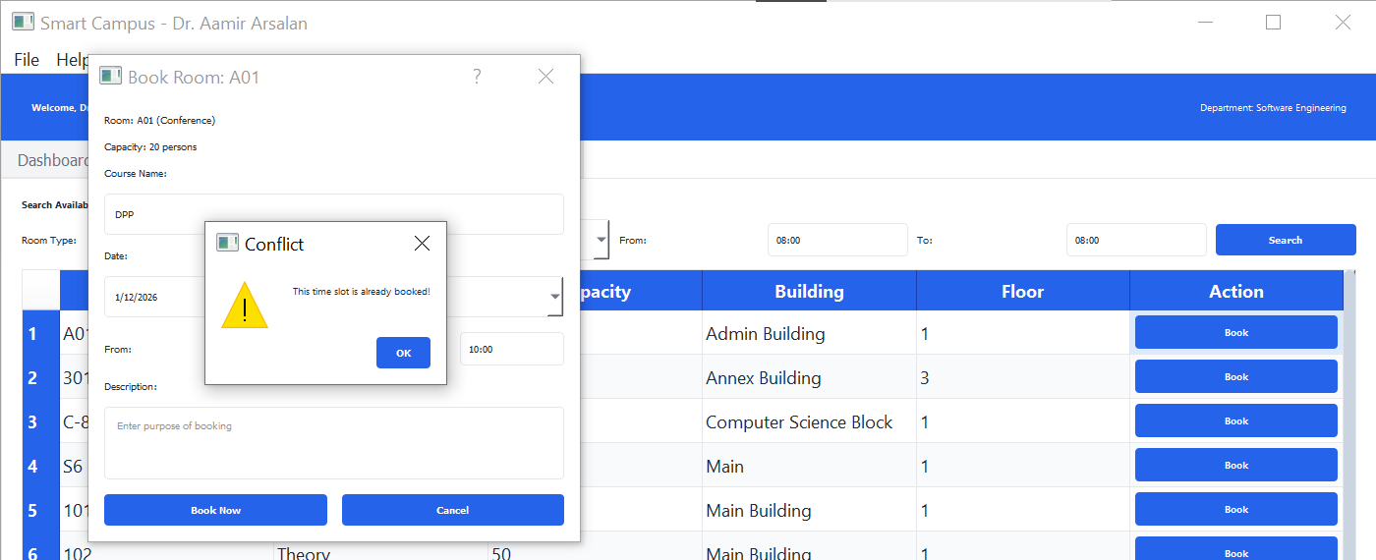

Conflict Detection Logic:
def check_conflict(classroom_id, booking_date, start_time, end_time):
# Check if any existing booking overlaps
query = '''
SELECT * FROM bookings
WHERE classroom_id = ?
AND booking_date = ?
AND status != 0 # Exclude cancelled bookings
AND (
(start_time <= ? AND end_time > ?) OR
(start_time < ? AND end_time >= ?) OR
(start_time >= ? AND end_time <= ?)
)
'''
# Returns True if conflict found

6.3.6 Implementation Details
Files: - models/booking.py: Booking model with CRUD operations - gui/admin_dashboard.py: Admin booking management interface - gui/user_dashboard.py: User booking interface - gui/dialogs_edit.py: Edit booking dialog
Key Methods:
Booking.create()
Booking.get_all()
Booking.get_user_bookings(user_id)
Booking.check_conflict()
Booking.update()
Booking.delete()

6.4 Schedule Management Module

6.4.1 Overview
Manages class timetables, teacher schedules, and section-wise class allocation.

6.4.2 Features
- Create class schedules with course details
- Assign teachers to courses
- Allocate classrooms for classes
- Detect schedule conflicts
- View teacher-specific schedules
- View student section schedules
- Edit and delete schedules

6.4.3 Schedule Attributes
- Course Code (e.g., SCD-501)
- Course Name
- Teacher Assignment
- Classroom Assignment
- Day of Week (Monday-Friday)
- Time Slot (Start Time - End Time)
- Semester Number
- Section (A, B, C, etc.)
- Academic Session
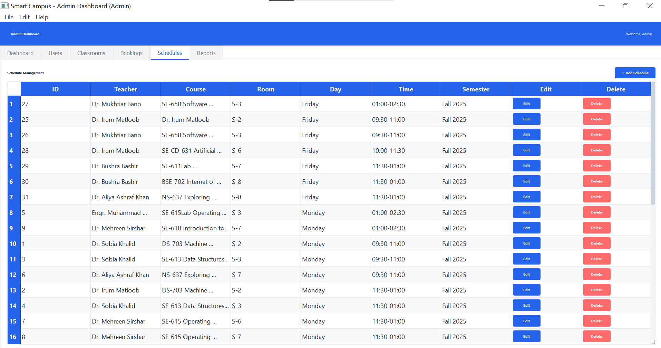

6.4.4 Schedule Conflict Detection
Prevents scheduling conflicts by checking: - Same teacher cannot be scheduled in two places simultaneously - Same classroom cannot host two classes simultaneously - Same section cannot have overlapping classes

6.4.5 Implementation
Files: - models/schedule.py: Schedule model - gui/admin_dashboard.py: Schedule management interface (Schedules tab) - gui/user_dashboard.py: View schedules (My Schedules tab for teachers)
Key Methods:
Schedule.create()
Schedule.get_all()
Schedule.get_teacher_schedule(teacher_id)
Schedule.get_section_schedule(semester, section)
Schedule.check_conflict()

6.5 Reporting and Analytics Module

6.5.1 Overview
Generates comprehensive reports and data visualizations for administrative decision-making.

6.5.2 Report Types
1. Resource Usage Report - Lists all classrooms with utilization statistics - Shows booking frequency - Identifies underutilized resources - Format: Text file with tabular data
2. Booking Statistics Report - Total bookings count - Bookings by status (Approved, Pending, Rejected, Cancelled) - Bookings by room type - Peak booking times - Format: Text file with summary statistics
3. Teacher Schedule Report - Individual teacher’s complete schedule - Course load analysis - Room assignments - Format: Text file with weekly timetable
4. Data Export Report - Complete database export - All bookings with details - Format: CSV file for Excel/spreadsheet analysis

6.5.3 Data Visualizations
Analytics Dashboard Features: 1. Booking Status Pie Chart - Visual distribution of booking statuses - Color-coded segments (Green, Orange, Red, Purple) - Percentage labels
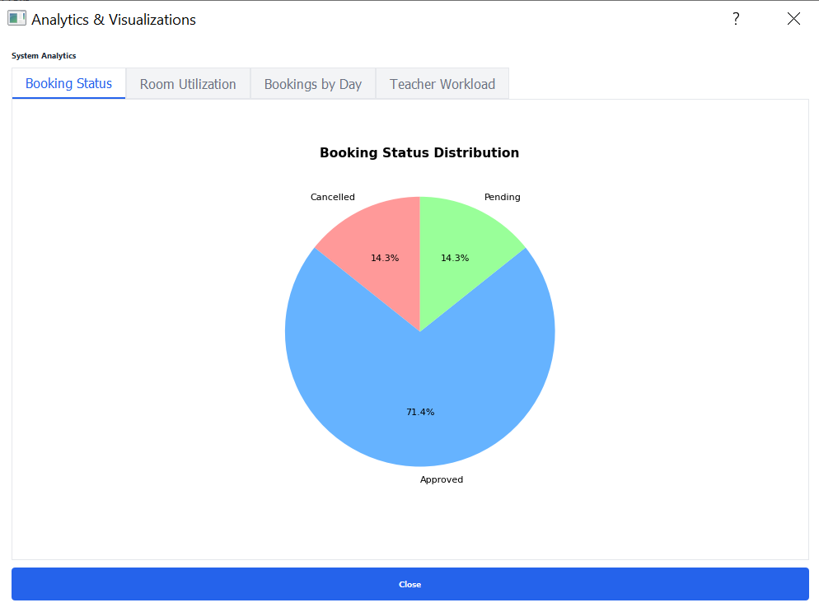
- Room Utilization Bar Chart
  - Horizontal bars showing utilization per classroom
  - Percentage-based comparison
  - Identifies most/least used rooms
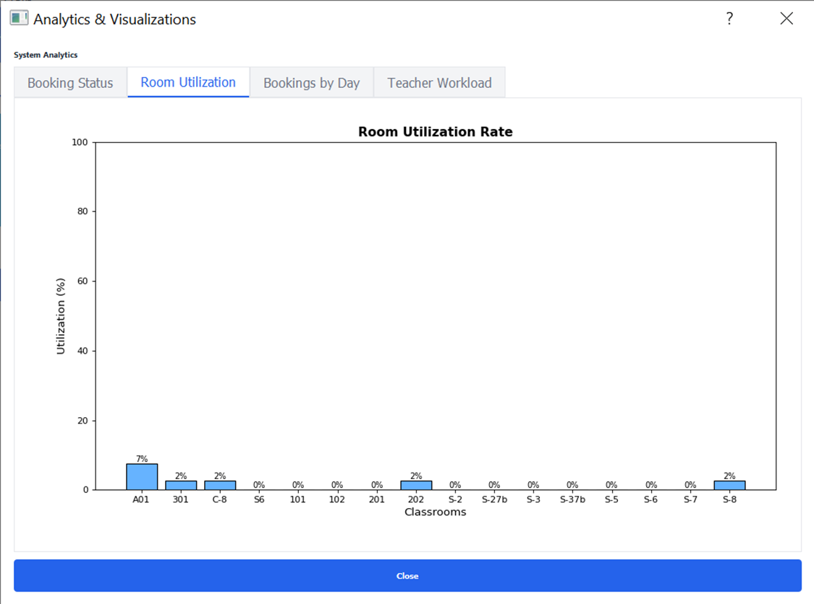
- Bookings by Day Line Chart
  - Trend analysis of bookings across weekdays
  - Identifies peak days
  - Area fill for visual clarity
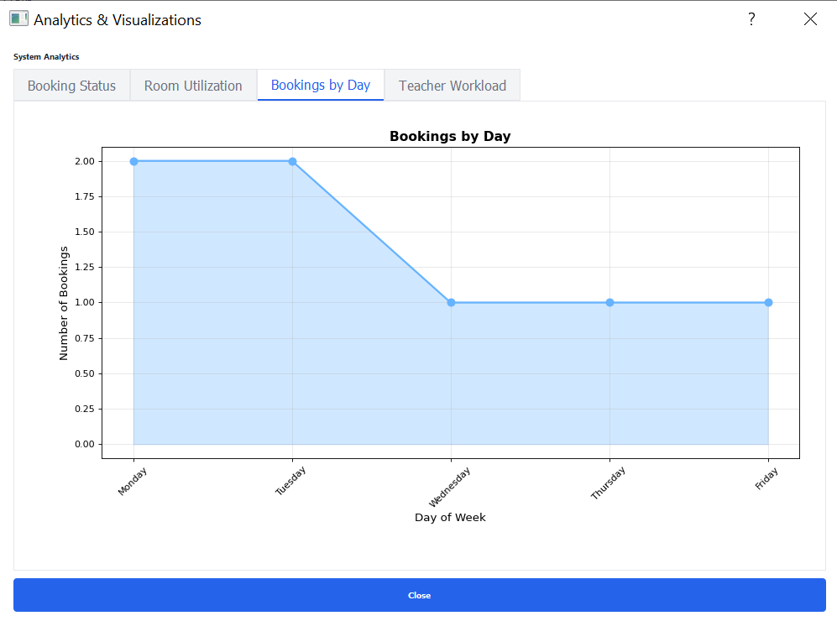
- Teacher Workload Bar Chart
  - Compares class count per teacher
  - Top 10 teachers by workload
  - Helps balance teaching assignments

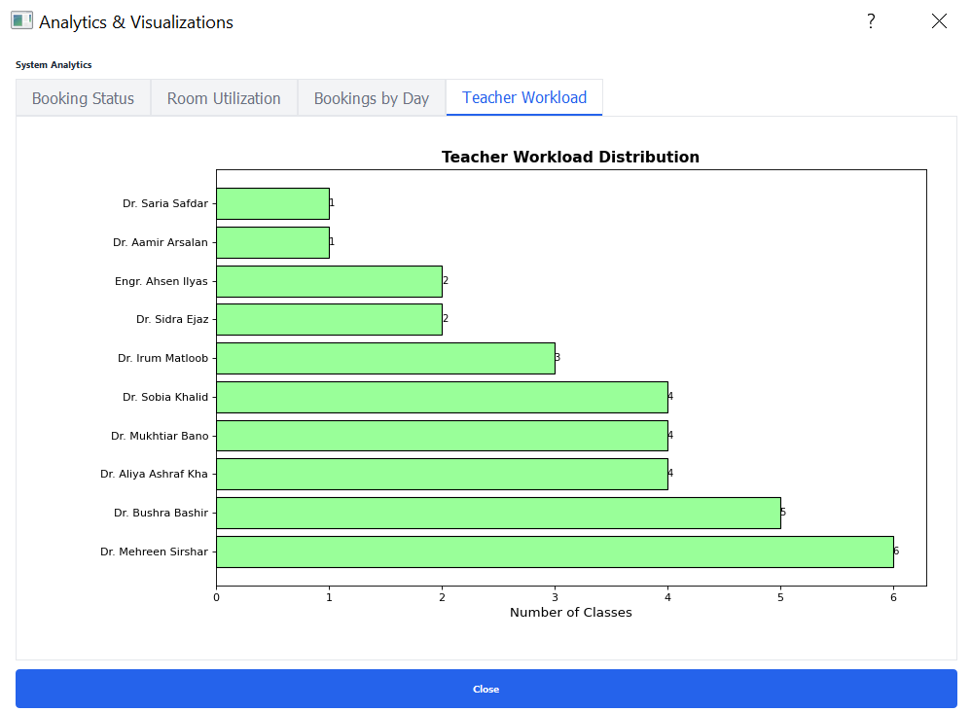

6.5.4 Implementation
Files: - reports/usage_report.py: Report generation logic - utils/visualization.py: Chart creation with matplotlib - gui/admin_dashboard.py: Report generation interface and analytics display
Key Methods:
generate_resource_usage_report()
generate_booking_statistics_report()
generate_teacher_schedule_report()
export_data_to_csv()
show_analytics() # Opens analytics dashboard

7. User Roles and Access Control

7.1 Administrator Role

7.1.1 Permissions
Administrators have complete system access with full CRUD operations on all entities.

7.1.2 Capabilities
User Management: - View all users - Add new users - Edit user information (name, email, phone, department, status) - Delete users - Manage user roles and status
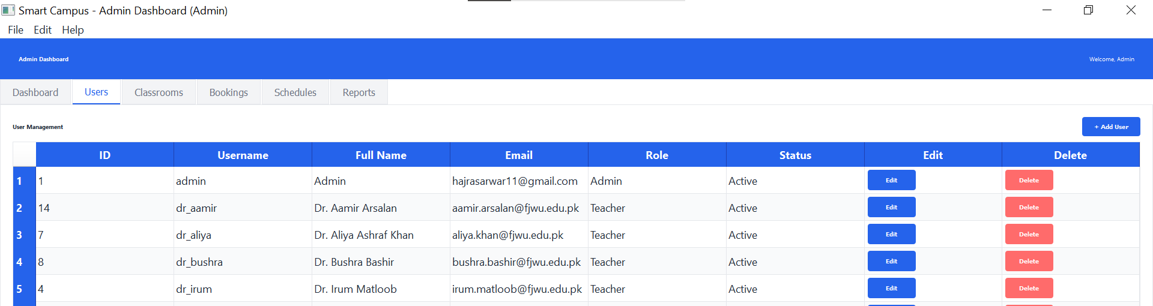
Classroom Management: - Add new classrooms - Edit classroom details - Delete classrooms - Generate QR codes for classrooms - View classroom utilization
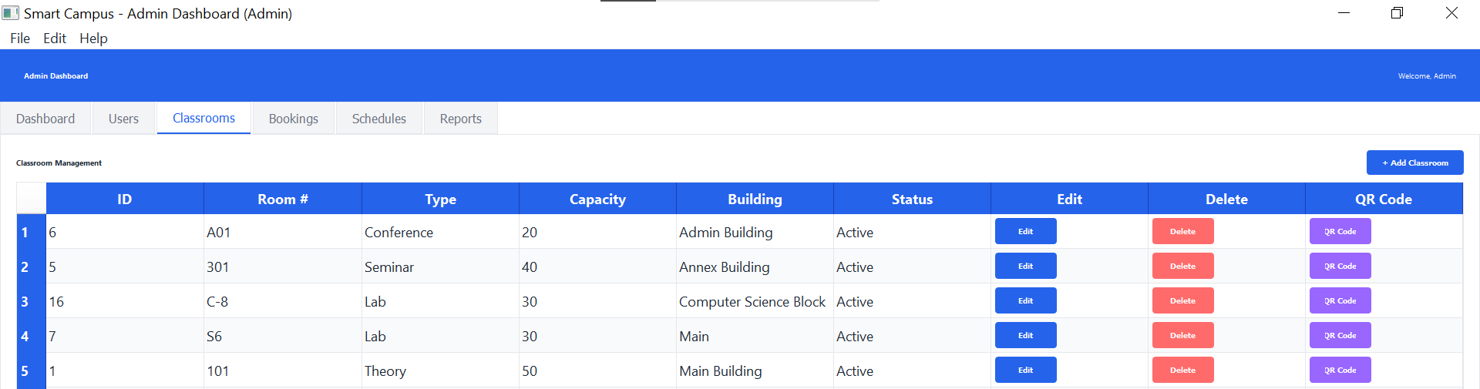
Booking Management: - View all booking requests - Approve bookings - Reject bookings - Cancel bookings - Edit booking details - Delete bookings - Filter bookings by status
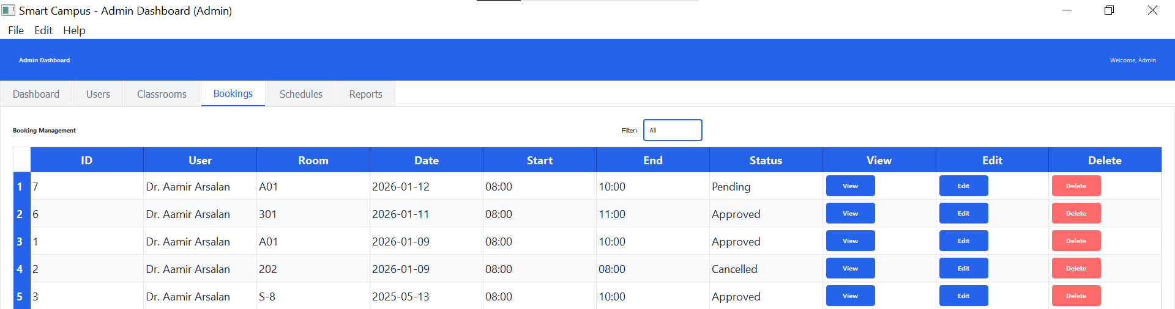
Schedule Management: - Create class schedules - Edit schedules - Delete schedules - Assign teachers to courses - Allocate classrooms - View all schedules
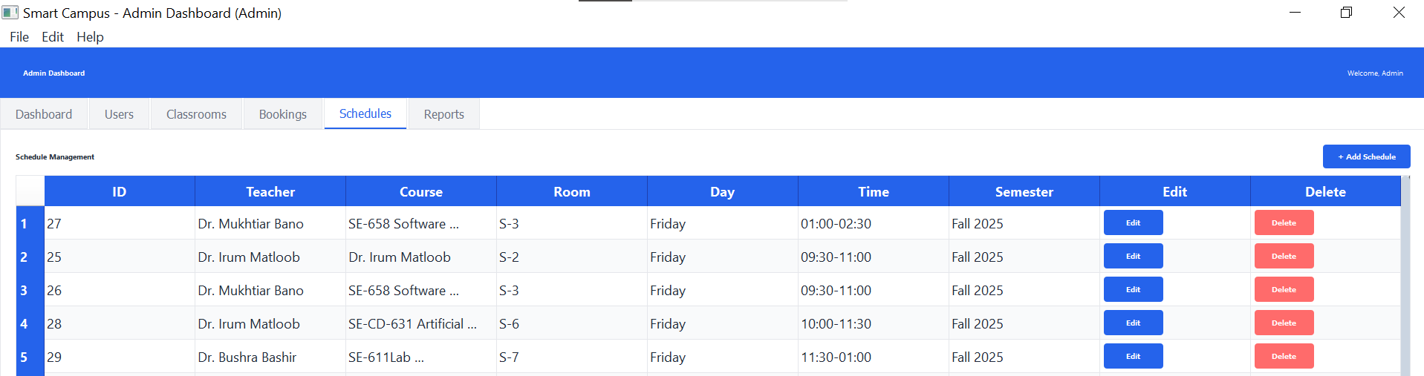
Reports and Analytics: - Generate all types of reports - View analytics dashboard - Export data to CSV - Access usage statistics
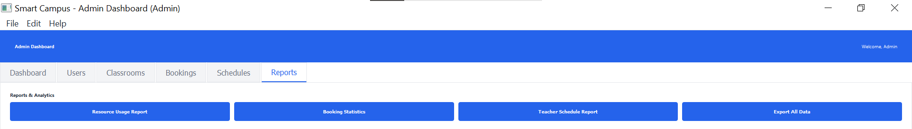
System Configuration: - View system settings - Access help documentation - Manage system preferences
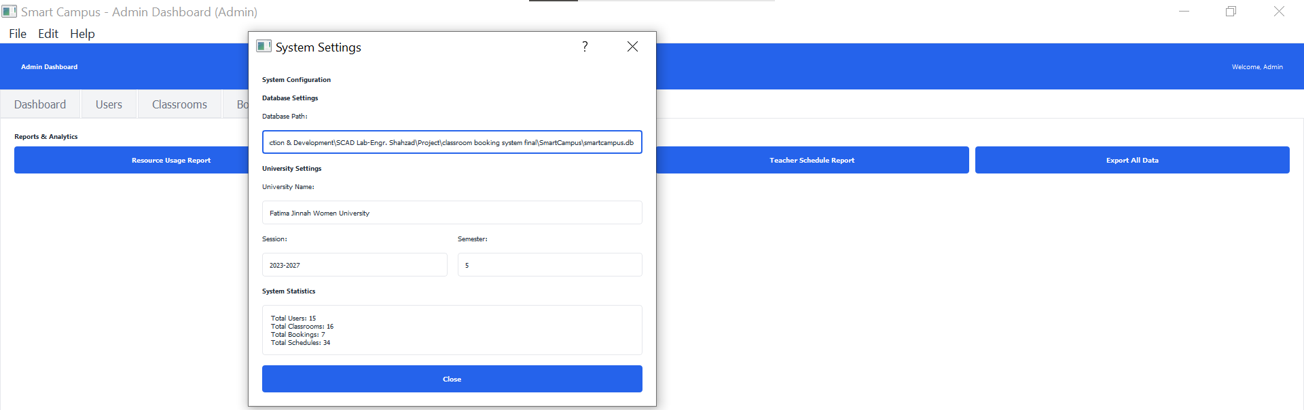

7.1.3 Dashboard Features
Statistics Cards: - Total Users count - Total Classrooms count - Total Bookings count - Pending Approvals count
Quick Actions: - Add User - Add Classroom - View Bookings - View Analytics - Generate Report
Navigation Tabs: 1. Dashboard (Overview) 2. Users (User management) 3. Classrooms (Resource management) 4. Bookings (Booking approval) 5. Schedules (Timetable management) 6. Reports (Report generation)
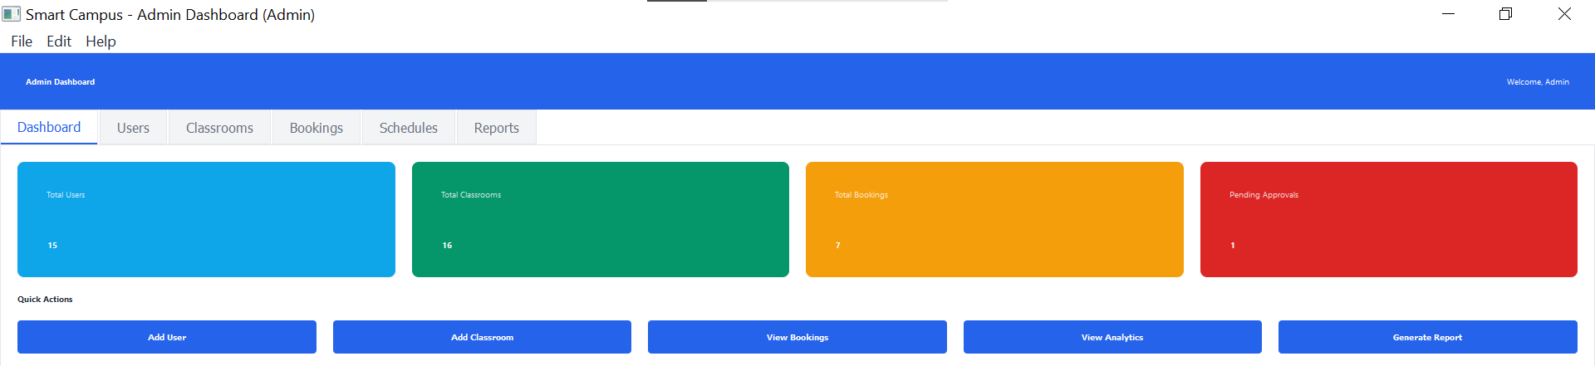

7.2 Teacher Role

7.2.1 Permissions
Teachers have limited access focused on their teaching activities and booking needs.

7.2.2 Capabilities
Booking Management: - Create booking requests for classrooms - View own booking history - Edit pending bookings - Cancel own bookings - Export own bookings to CSV
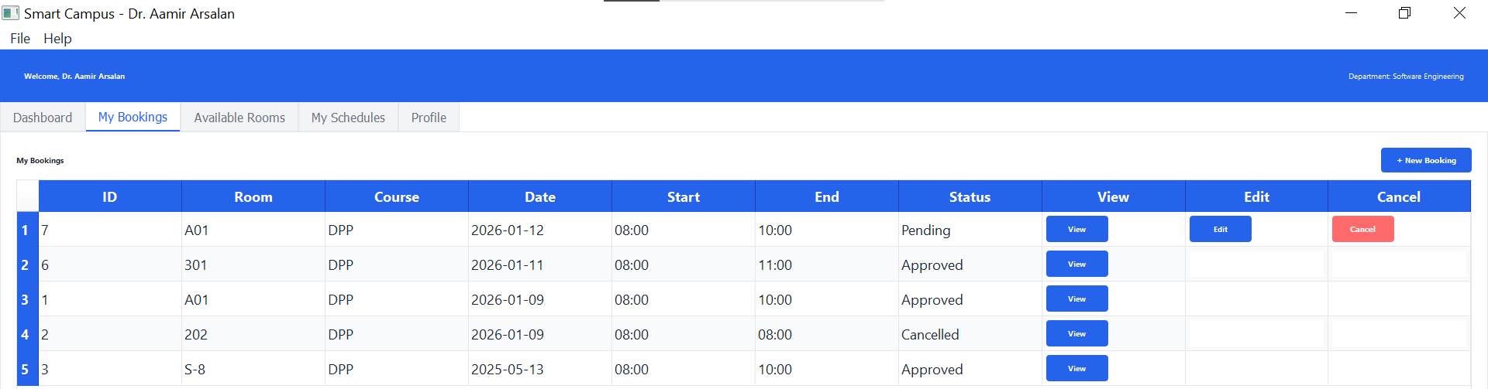
Schedule Management: - View own teaching schedule - See assigned classrooms - View course details
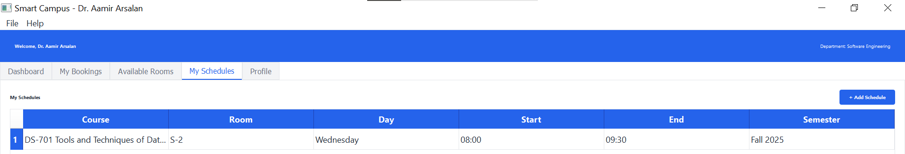
Profile Management: - Edit own profile (name, email, phone) - Change password - View account details
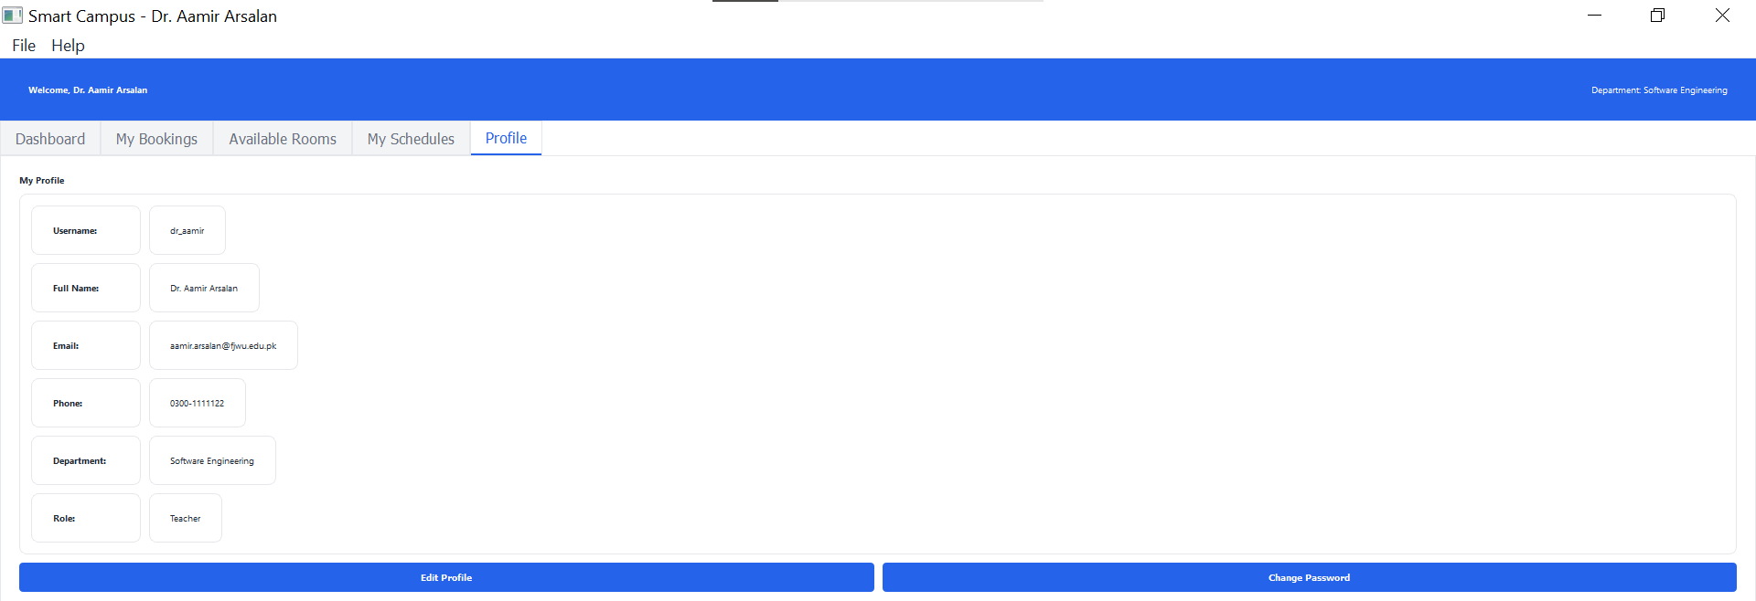
Resource Discovery: - Search available classrooms - Filter by room type, capacity, building - View classroom details
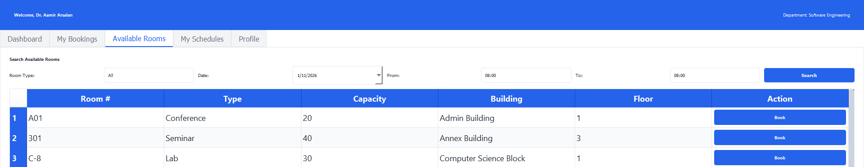
Support: - Access help documentation - Contact support (hajrasarwar11@gmail.com, 03273456789)
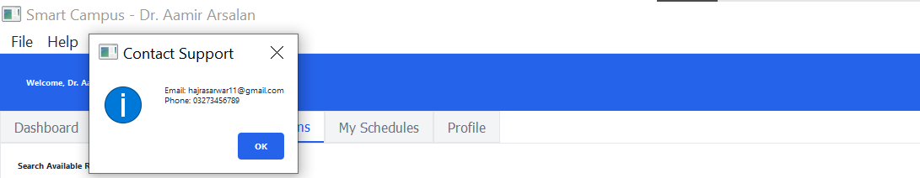

7.2.3 Dashboard Features
Statistics Cards: - Total Bookings (personal) - Approved Bookings (personal) - Pending Bookings (personal)
Quick Actions: - New Booking (disabled if already has pending) - Export Bookings - View Schedule - Contact Support
Navigation Tabs: 1. Dashboard (Overview) 2. My Bookings (Personal booking history) 3. Available Rooms (Search classrooms) 4. My Schedules (Teaching timetable) 5. Profile (Personal information)
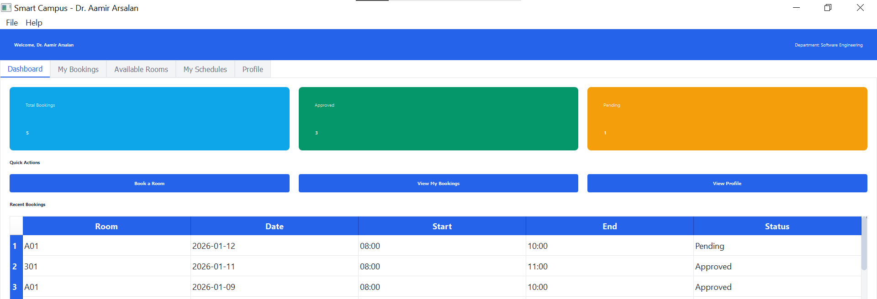

7.3 Student Role

7.3.1 Permissions
Students have read-only access to their class schedules and limited profile management.

7.3.2 Capabilities
Schedule Access: - View own section’s class schedule - See course details - View teacher assignments
Profile Management: - View profile information - Edit profile (name, email, phone) - Change password
Information Access: - View department information - View session and semester details - Access help documentation - Contact support
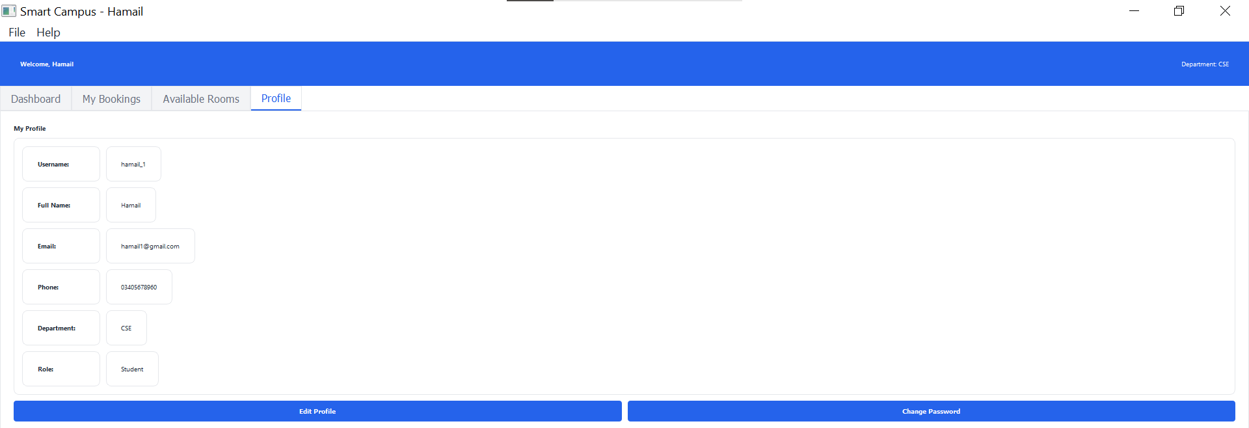

7.3.3 Dashboard Features
Statistics Cards: - Total Classes (section-based) - Department - Semester - Section
Quick Actions: - View Schedule - Edit Profile - Contact Support
Navigation Tabs: 1. Dashboard (Overview with statistics) 2. My Schedules (Class timetable for section) 3. Profile (Personal information)
